Step 1:
Visit www.laveeneld.org
Step 2:
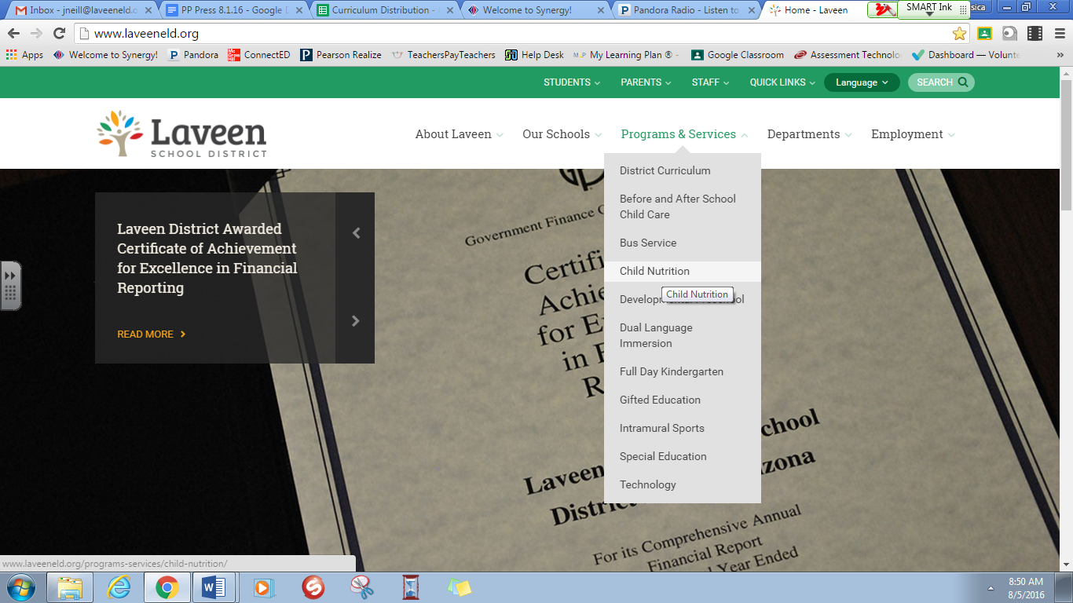
Click on Child Nutrition under the Program & Services tab
Step 3:
Click on Free and Reduced Price Meal Application
